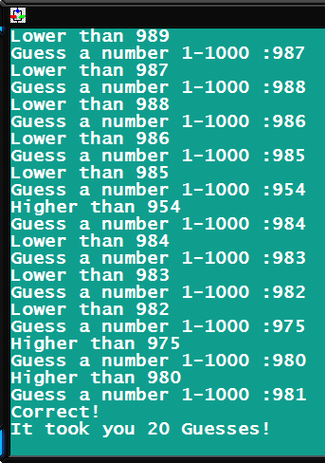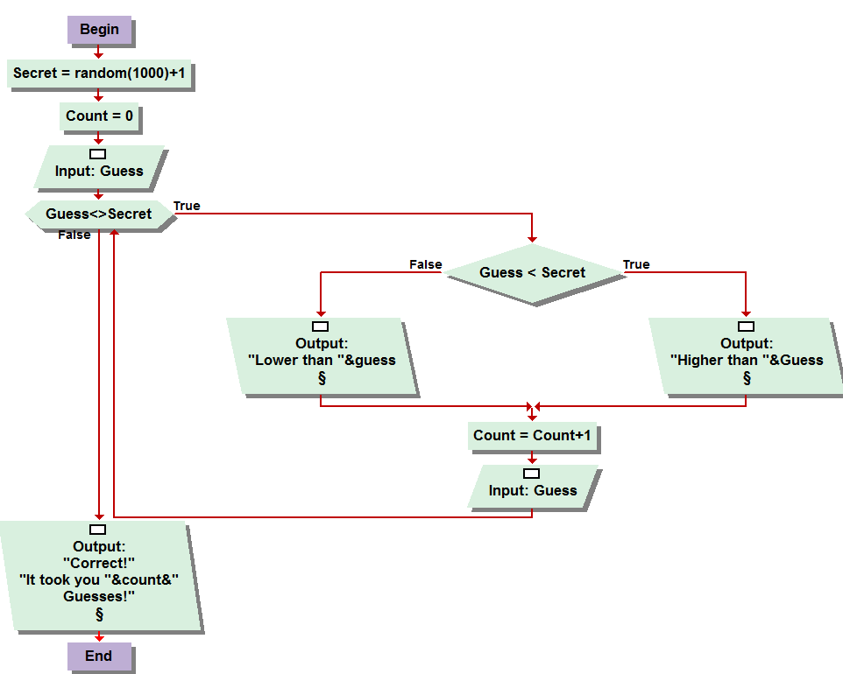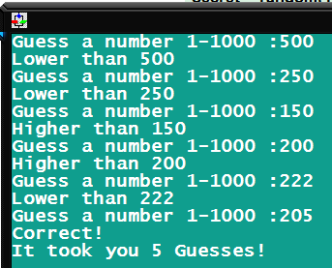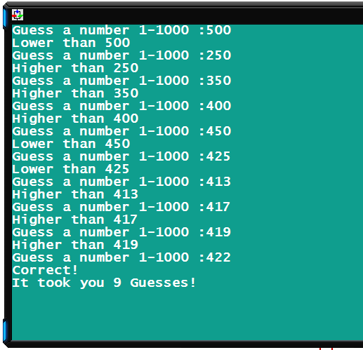

3.9. Okay so I had a lot of fun with this, infact I challenged my whole household to play it, saved it to a usb and am gonna play against my parents when I see them next, this was soo cool. Growing up in the gaming generation to make an actual game, no matter how primitive, is pretty neat. The foundation was outlined in the book, I just didn’t use a actual “exit loop” function or an infinite loop. The while loop prompts for guesses as long as the guess <> secret. If its higher, it says its higher and vice versa. Then the basic count counter for the skill determiner, which I now have the record for in the house with this score right to the right! =>  
finally when its reached, it congratulates you and gives you the guesses. So fun, so fun!

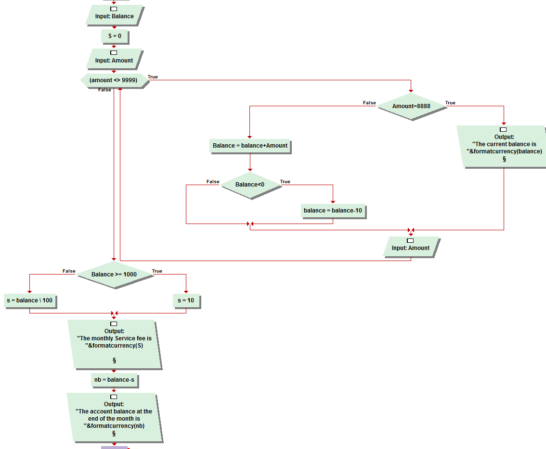

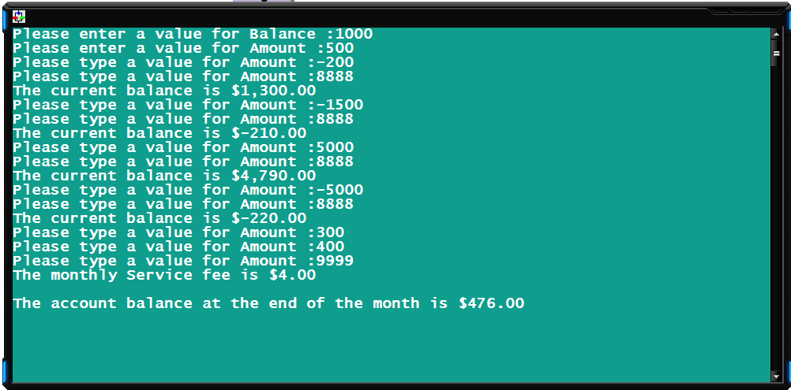

3.10 Account balancer. Having some difficulties with my word, Errrg! Anyway. I’m starting with this one because it was challenging. First an input, for the starting balance, then I assigned “s” to zero, which is a variable I use for Service fee. Followed by an input for amount. The while loop is conditionally occurring if the sentinel value of 9999 is not entered for the amount. So while this is true, another condition, of sentinel 8888, determines whether to display the current balance, or add the amount of the amount variable to the balance. If this causes the balance to go below zero, a ten dollar deduction occurs. You then input another amount for amount. Provided it does not trigger a sentinel, the process repeats until then. When 8888 is entered, the current balance is displayed and prompts for another input, and continues to do so until 9999 is entered, which then calculates the monthly service fee, outputs that and the adjusted total balance, which is the balance minus the service fee. If the balance is over 1000 dollars, it is a flat fee of 10 dollars a month, otherwise, I used an integer division formula to calculate one dollar per hundred to be deducted as the monthly service fee. My spacing of the console commands are not as precisely crafted throughout the program, but it does the very essence of the program, just a little more space saving!

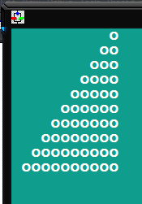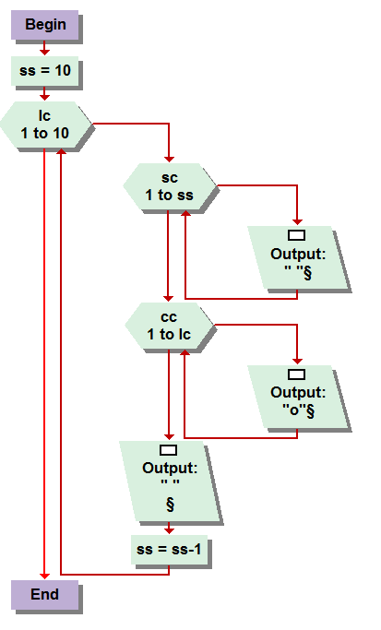

The following I, after further review of the week 4 course document, realize are not required of this week’s assignment. Regardless of whether we need to complete them in the future or not, in case we don’t I feel like I need to submit them for your approval considering I have already done them and, even if I receive no credit, don’t want to feel like I completely wasted my time, which they did infact require some.   
  
4.6 this one was pretty easy to work out, and layed the floor plan for the problems to follow. Figure 4-14 layed the ground work, then it was just a simple process of including a space counter , as mentioned by the question itself, to create the appropriate distance between the circles causing it to appear similarly to the picture in the document , but as if seen in a mirror.

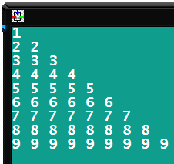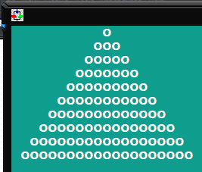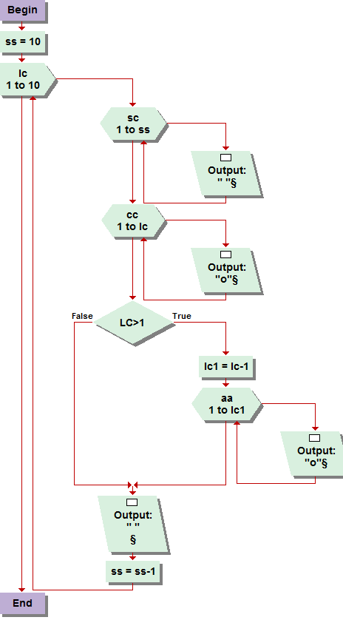

4.7  
This one really got the noodle working. It required many loops as well as a if condition nest all inside a line count loop after u assign a value to ten, ss, which I cannot remember what it stances for, I think its suppose to represent Sircle, lol spacer. Haha but anyway you have the same basic formula for the previousta, but inorder to create the tree shape, you create a loop to form figure 4-14 pattern only if the value of line count is greater then one, this also allows all the circles to exist in an odd number of circles per line. Which, I will admit, I had trouble doing at first. All of these problems took some serious playing with, getting poor results, and re-tweaking, before they came out correct.

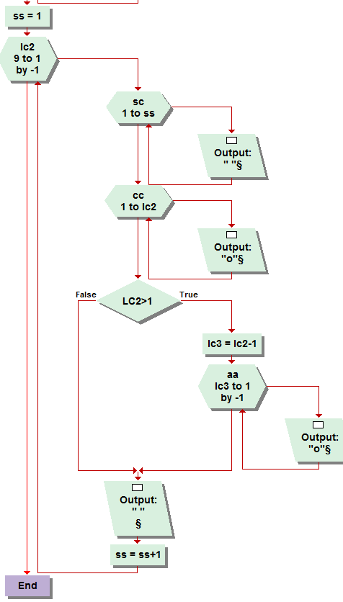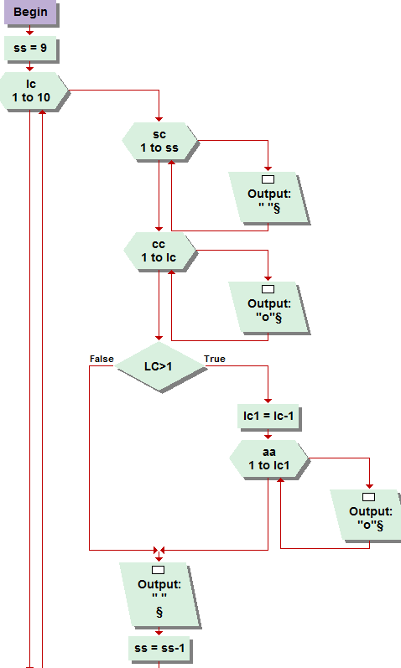

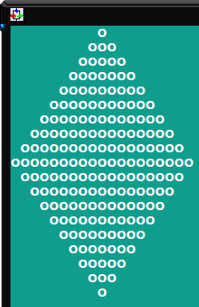

4.8  
The ultimate mind blower. This problem took me a long time to figure out, because I made foolish typo’s . I had it right from the start, with converting and inverting each set of loops to form each quadrant of the diamond. Started with the tree formula, inverted and converted for the first quadrant but had a typo for the bottom right quadrant, mainly because I was lazy and used similar abbreviations over and over and got myself confused and had the wrong assignments and loops converting the wrong set of variables. I don’t know exactly how to explain it. Its really quite complicated. And required a good 45 minuets of serious dedication to uncracking. Manily through trial and error, I was able to work out the kinks in conversion and inversion to create the desired result. It was a good deal of fun and I am rather quite proud that I figured it out.